UNIT 5 TEST

Name: Class:

1 5T ⑤ Posłuchaj i ponumeruj. Listen and number.
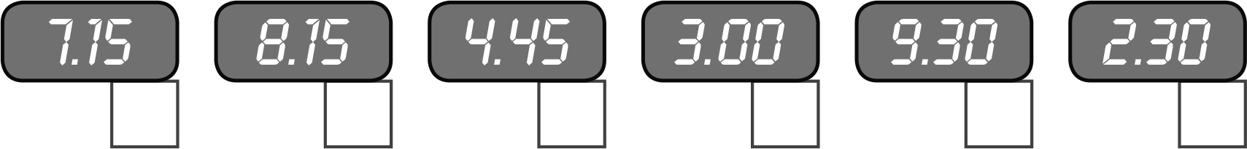
  6
2 Przeczytaj i wpisz litery. Read and write the letters.
1 | He gets up at quarter to eight.  | 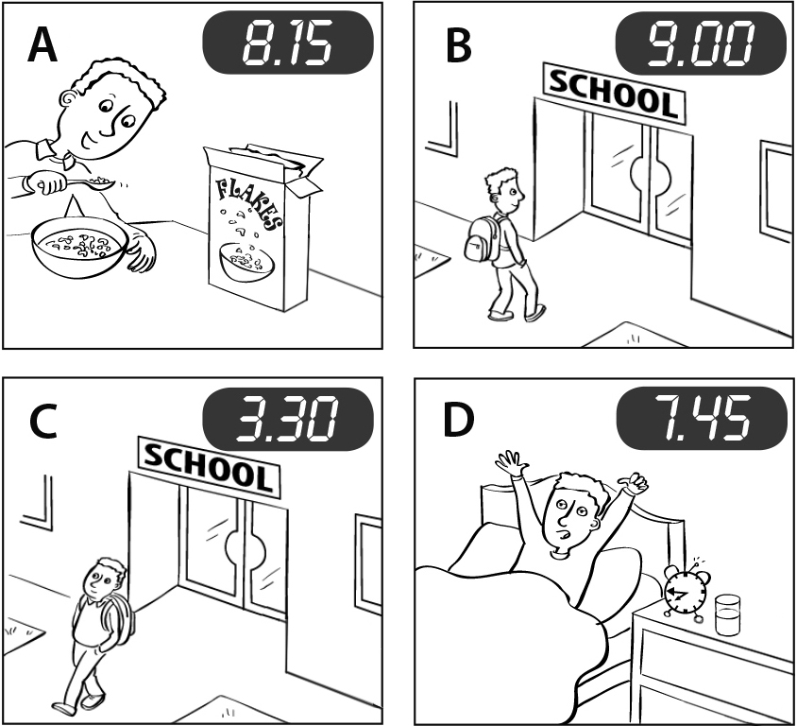
2 | He has breakfast at quarter past eight.
3 | He goes to school at nine o’clock.
4 | He goes home at half past three.
  4
3 Przeczytaj. Wybierz i napisz. Read. Choose and write.
do watch get up have go

I my homework at 6.45.
I to bed at 9.15.

I at 7.15.
and I a shower at 7.30.
  4
  14

Young Treetops 3 © Oxford University Press

