UNIT 6 TEST

1 Podpisz obrazki. Write.
a kite a bike a bracelet a poster a helmet

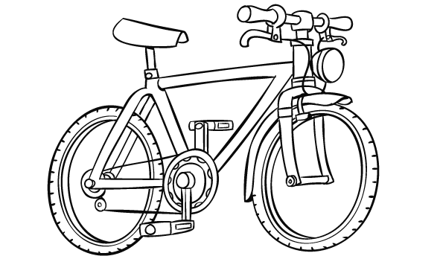  1 | 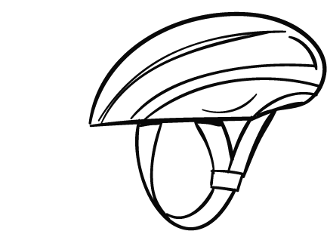  2 | 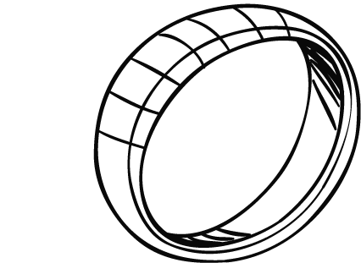  3
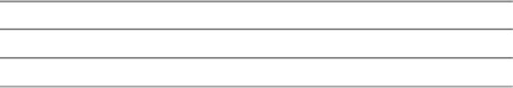
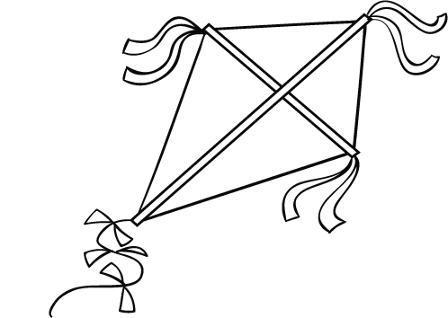  4 | 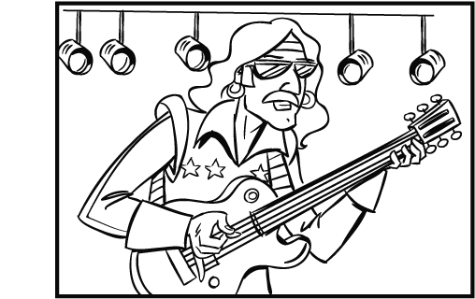  5
  5
2 Popatrz, przeczytaj i wstaw () lub ( ). Look, read and tick () or cross ().
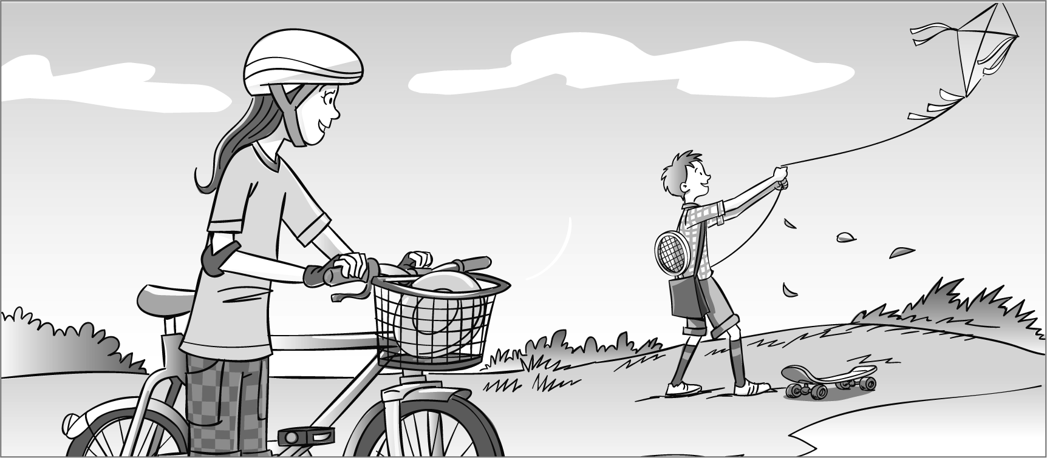

1 She’s got a kite. |  | 2 He’s got a helmet.
3 He’s got a racket. |  | 4 She’s got a Frisbee.
5 She’s got a skateboard.
  5

3 Popatrz, zakreśl i napisz. Look, circle and write.
Frisbee bracelet poster skateboard racket
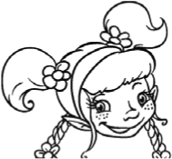
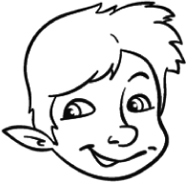
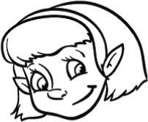
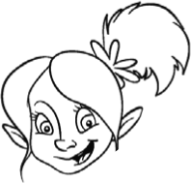  1 |  | He’s / She’s got a | 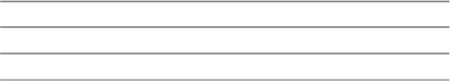 | . | 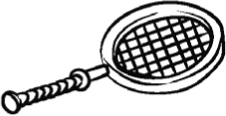
2 |  | He’s / She’s got a |  | . | 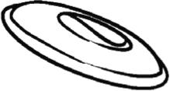
3 |  | He’s / She’s got a |  | . | 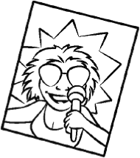
4 | 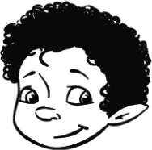 | He’s / She’s got a |  | . | 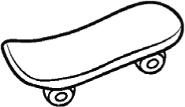
5 |  | He’s / She’s got a |  | . | 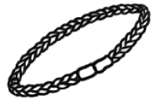
5
15

