1. Popatrz i wstaw we właściwe miejce.

in on under

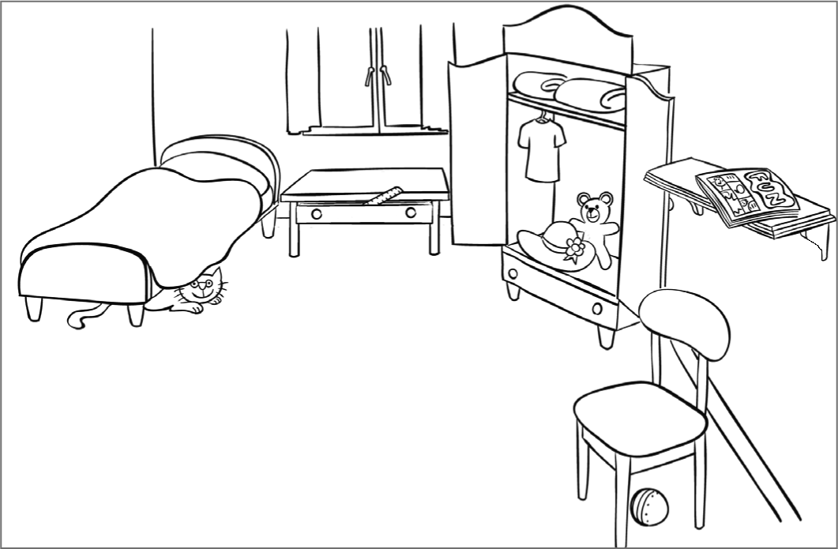

The cat is _________ the bed.

There's a teddy bear _________ the wardrobe.

There's a comic ___________ the bookshelf.

There's a ruler ___________ the drawer.

There's a ball ____________ the chair.

2. Przeczytaj opis i narysuj:

There's a green ball under the bed. There's a yellow lamp on the drawers. There are two blue books on the bookshelf. There's a black cat on the bed. There's a purple umbrella in the wardrobe.

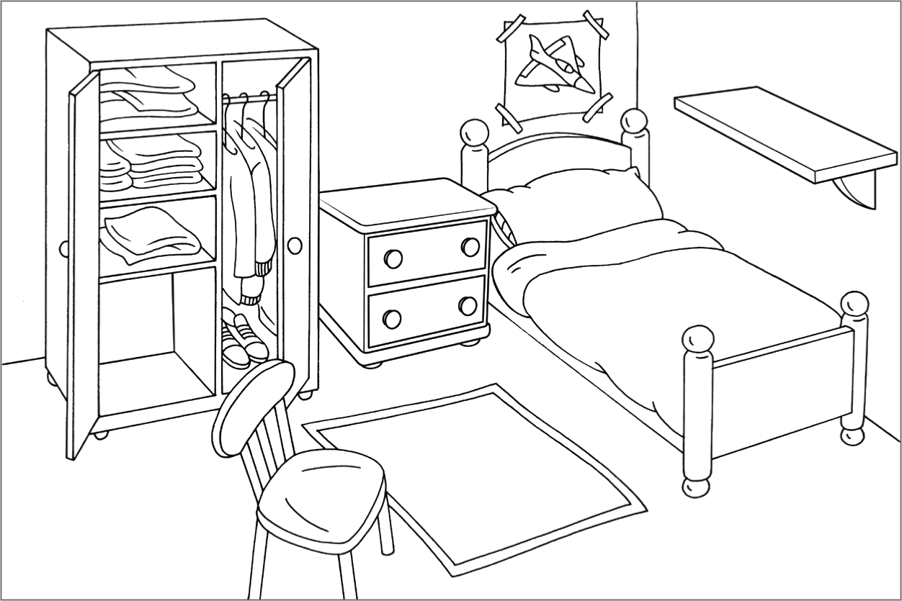

Źródło: Explore Treetops klasa II. Testy, Oxford

